AGENCY

Protected Utility

AGENCY - SOP - Renew VPP Token - Admin
 | 
Date 23 September 2020

Document Information

Document Acceptance for v1.0
Function | Date | Name | Position
Prepared: | 14-09-2020 | Collin McKeahnie | Consultant
Reviewed | 21-09-2020 | Mathew Laurence-Rogers | Managing Consultant
Released | 23-09-2020 | Mathew Laurence-Rogers | Managing Consultant

Drafting and Release History
Version | Date | Author | Description
0.1 | 14-09-2020 | Collin McKeahnie | Initial Document
0.2 | 21-09-2020 | Mathew Laurence-Rogers | Review and update
1.0 | 23-09-2020 | Mathew Laurence-Rogers | Release

oobe contact details | oobe Pty Ltd
oobe contact details | | www.oobe.com.au  | GPO 111 Canberra City 2601  | ACN 123 977 846  | ABN 48 123 977 846

Contents
Renew VPP Token 4
Introduction 4
Purpose 4
Audience 4
Pre-Requisites 4
Renew VPP Token 5

Renew VPP Token

Introduction
The Volume Purchase Program (VPP) is an Apple service designed to simplify the process of purchasing and distributing corporate mobile applications. It requires a token to be generated in the Apple Business Manager and uploaded into Microsoft Intune. This token has a validity of 365 days.

Purpose
This document is to guide an admin user through the process of renewing the MDM server token which is required to link the AGENCY Apple Business Manager account to Intune.

Audience
Admin users

Pre-Requisites
- Apple Business Manager account has been set up. The admin attempting the work has permission to access the portal.

Renew VPP Token
Step | Instruction | Screen Shot
 | Log into the Apple Business Manager Account at https://business.apple.com  Username: applemobile@AGENCY.gov.au  Password: Stored by AGENCY | 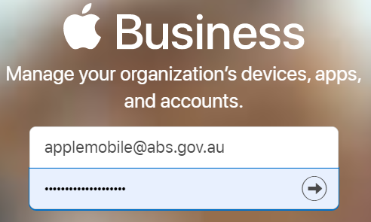
 | Select Settings from the bottom of the left side menu | 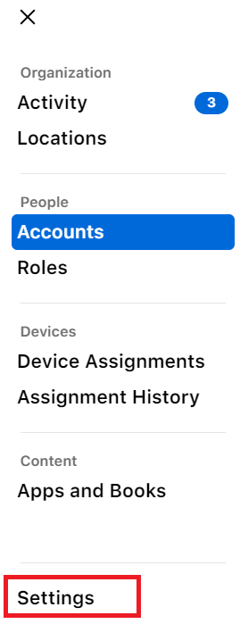
 | Select Apps and Books from the settings menu | 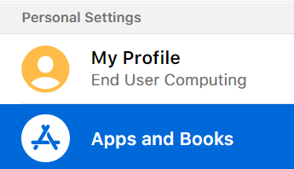
 | Under My Server Tokens Click the Download | 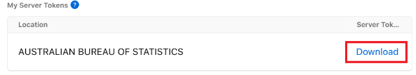
 | Log into the Microsoft Endpoint Manager at https://endpoint.microsoft.com and select Tenant administration | 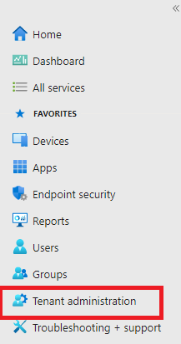
 | From the Tenant administration blade select Connectors and tokens | 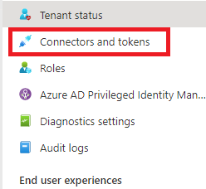
 | From the Connectors and tokens blade select Apple VPP Tokens | 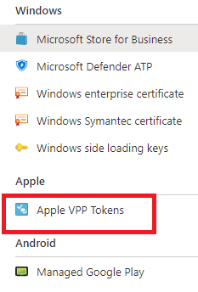
 | Any AGENCY Apple VPP tokens will be visible here | 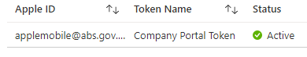
 | Select create | 
 | Create the token. Uploading the file obtained in step 4 | 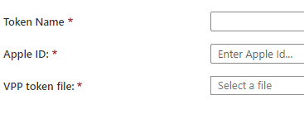
 | The AGENCY Apple VPP token will be now be shown on the Apple VPP Tokens page
 | From the end of the row click the three dots and then press Sync  This will tell Intune to refresh the status of all the app licences with Apple. | 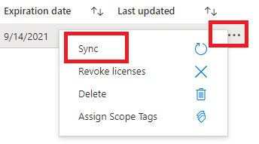
 | Log into the Microsoft Endpoint Manager at https://endpoint.microsoft.com and select Devices | 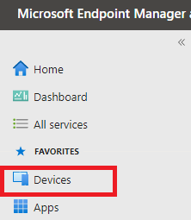
 | From the devices blade select iOS/iPadOS | 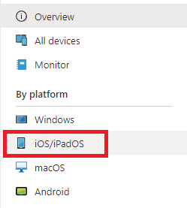
 | From the iOS/iPadOS blade select iOS/iPadOS enrolment | 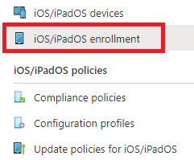
 | Under Bulk enrolment methods select Enrolment program tokens | 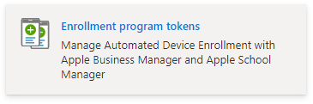
 | Select the Token name for the appropriate Apple ID | 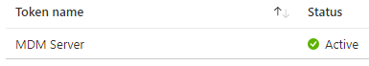
 | Select Profiles | 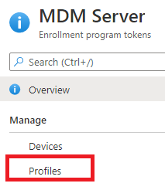
 | Select the profile for which you want to renew the VPP token | 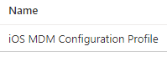
 | In the profile’s blade select Properties | 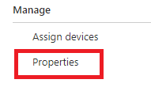
 | Under Management Settings select Edit | 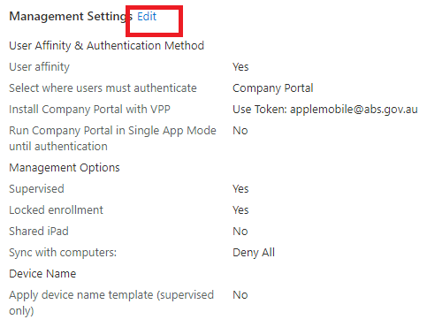
 | Ensure that the Install Company Portal with VPP is set to Use Token and the token is the one configured earlier.

